**Report**

Abstract:

In this assignment we have implemented the file sharing and various other functionalities such as deleting files, viewing files, upload and download etc. from the remote server. The client can also see the upload and download speed with the help of graphs and texts.

Introduction and Motivation:

Both server and client has their separate folders, in which there files are present. Both the client and server can share the files from these folders only. Client is provided 4 commands namely –

UPLOAD – To upload files into server folder from client folder.

DOWNLOAD – To download files from server folder.

DIR – To view the files currently present in server folder.

DELETE – To delete any file from server folder.

Project Design and Implementation:

Server- The server has 3 functions – receive_file, send_file and delete_file

First we have created the socket for the server and also bind it with a IP address and a PORT number.

Receive_file() function is used when the client uploads the file into the server, this functions receives the file and saves it into the server.

Send_file() function is used when the client downloads the file from the server, this function send the data to the client.

Delete_file() function is used to delete the file from the server directory. It used the os module of the python.

Client – Client also has 3 functions – upload_file, receive_file and plot_graph

In this we have created the socket initially and the used connect() function to connect it to the server.

Upload_file() function is used to upload a file to the server directory.

Receive_file() function is used to receive/ download a file from the server.

Plort_graph() function is used to plot the graph between the speed and the time. The time is shown in microseconds and the speed is shown bytes/microsecond.

Experiments:

The following are the experiments performed along with the results obtained.

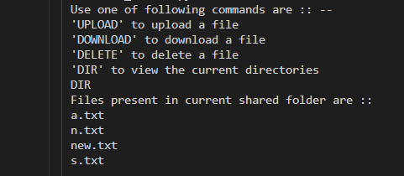

The above output is of the command DIR. This command is used to view the files present in our server folder currently.

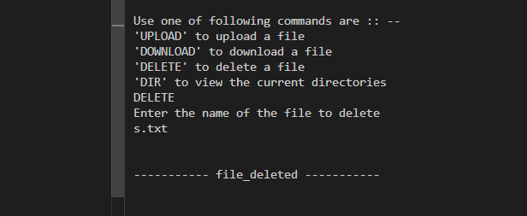

This is the output of the command DELETE, This command takes the name of the file to be deleted and then deletes the file from the server. If the filename entered doesn’t match any file name currently available in the server folder then an error message is thrown.

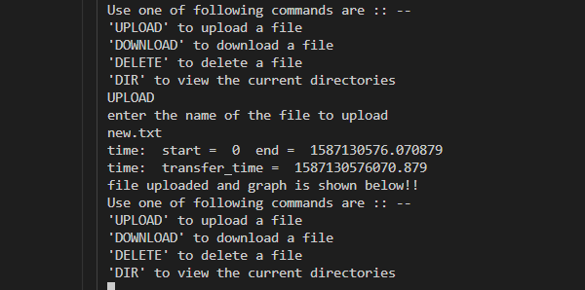

This is the output of the command UPLOAD. The user gives the name of the file to be uploaded.

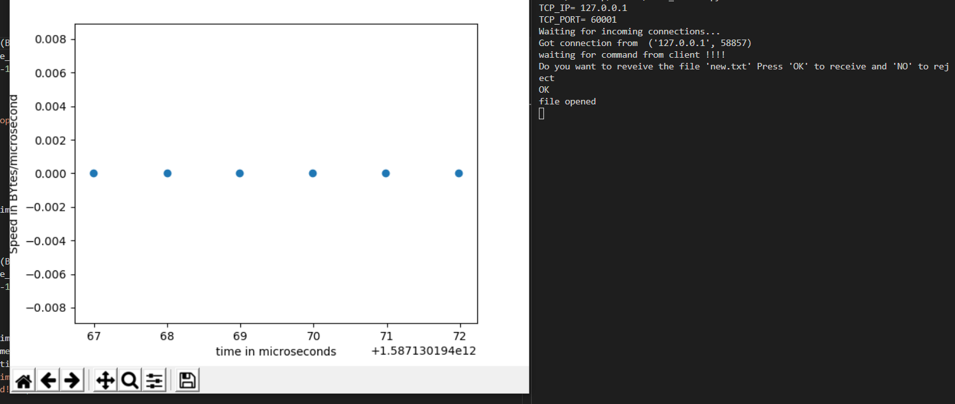

This the graphical display of the speed of the file transfer. The speed is in Bytes/microseconds. The time is in microseconds. The above graph depicts that the speed remains constant throughout the transfer.

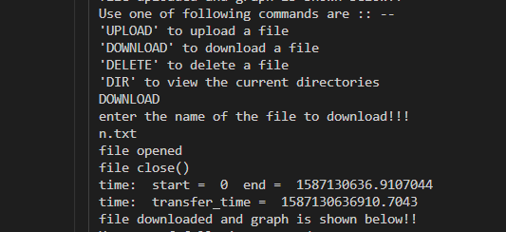

This is the output of the command DOWNLOAD, the user provides the name of the file to be downloaded, if no such file is present then an error message is displayed.

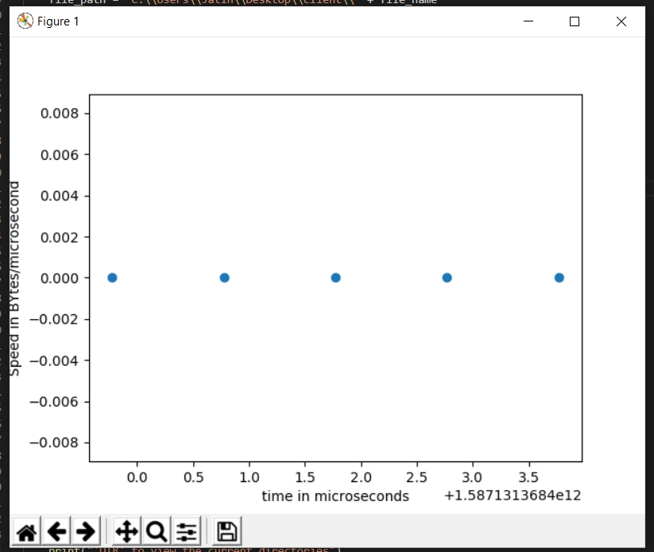

The above graph is showing the speed of the DOWNLOAD operation. The speed is in Bytes/microseconds. The time is in microseconds. The above graph depicts that the speed remains constant throughout the transfer.

Conclusion:

In this assignment we have successfully implemented the File UPLOAD, DOWNLOAD, DELETION AND DIR command with the help of python sockets. We have visualised the upload and the download speed of the files with the help of graphs using matplotlib library.